**BLOOD CELLS COUNTING**

**USING**

**COMPUTER VISION TECHNIQUES**

**NAME: K.Kokila**

**REG NO: 2019272016**

**CLASS: MCA-SS**

**GUIDE: Ms.G.MAHALAKSHMI**

**ABSTRACT:**

This paper proposes an automated method for counting of red blood cells using computer vision techniques. The traditional methods of blood analysis involve the manual counting of blood cells observed under the microscope. This method poses large dependency on the skills of the laboratory technician and can cause errors. The automated haematology analysers, on the other hand, produce accurate results.

However, these Equipment are very costly and difficult to move once installed. They require trained experts to operate this equipment. The proposes method provides a low cost and portable solution for obtaining the red blood cell count using a image processing algorithm that works on the images captured by a microscope with considerable accuracy.

The method minimizes the cost of the equipment while promoting mobility of the device for relocation to remote parts for pathological tests, all instructions and details of out will be printed to excel sheet with patient name as a report, so we manage more patient 's report effectively and handle with safe.

**INTRODUCTION:**

The manual counting of blood cells observed under the microscope. This method poses large dependency on the skills of the laboratory technician and can cause errors. The automated haematology analysers, on the other hand, produce accurate results.

However, these Equipment are very costly and difficult to move once installed. They require trained experts to operate this equipment. The proposes method provides a low cost and portable solution for obtaining the red blood cell count using a image processing algorithm that works on the images captured by a microscope with considerable accuracy.

Then it is digitally processed with software and the result is displayed immediately.

**PROBLEM STATEMENT**

* Mainly, Variations in the shape and irregularities cannot be detected.
* Sometimes, inaccurate results are produced through manual counting method and it adds stress to the technician while submitting the report. Therefore, counting overlapping cells is a major problem. To address this problem, this paper uses digital image processing technique to minimize the errors and reduce the stress overload.
* This method of counting RBC helps in diagnosing various diseases such as anaemia, polycythemia etc. This paper introduces a cost effective automatic blood cell counting method using image analysis techniques and specifically aims at improving the results using Plane extraction and Counting techniques. The proposed system of Automated Blood Cell Count System.

**ARCHITECTURE DIAGRAM:**

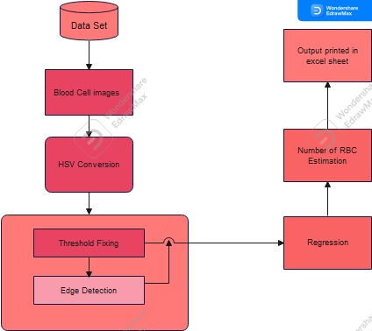

**Architecture Explain**

**RGB into HSV:**

R,G,B are Co-related to the color luminance, We cannot separate color information from luminance. HSV or Hue saturation value is used to separate image luminance for color information.

**Threshold define:**

Threshold is used to define minimum and maximum size of the cell.

**Edge Detections:**

Edge detection is used to define shape of given images and make line between color variations.

**Regression:**

Regression used to predict shape of the cells.

**Output:**

Display the output to the excel sheet

**Data Set Sample Image:**

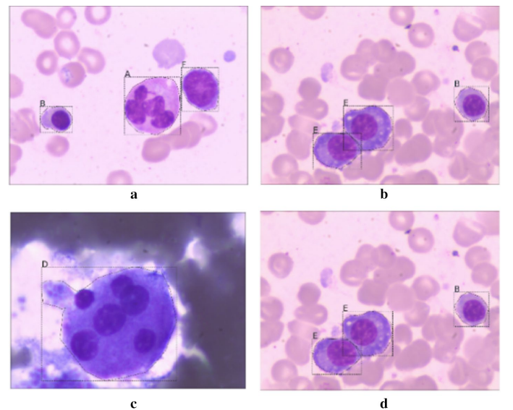

**MODULE AND MODULE DESCRIPTION:**

**Modules:**

* Image Processing
* Edge Detection
* Blood sample Acquisition

**Brief module description:**

Image Processing

The image obtained from the preprocessing step will be in RGB scale. For counting the Red blood cells, the red plane of the image will be extracted and the counting process is done. Similarly, for counting the White blood cells, the blue plane of the image is extracted and the counting process is applied.

Edge Detection

Edge preservation is an image processing technique to recover degraded and blurred images resulted while reducing the negative effect of noise in images. It can be a preliminary step toward better binarization and object segmentation. In this paper, Canny edge detection algorithm is used over on the noise removed image to mark the edges of the cells. Canny edge detection algorithm detected the edges of the cells with maximal accuracy in case of sharp images whereas the accuracy of cell detection reduced in blurry images. Since the cells are circular in shape, the edge detection was circular and complete. But in the case of practical images, after applying edge detection certain edges were incomplete.

Blood sample Acquisition

In this process, the slides are cleaned with ethanol using cotton. The fingers are cleaned with ethanol and are pricked with the help of Lancets. The blood drop is dropped onto the slide, smeared with another clean glass slide with an angle of 45 degrees inclination. Now the slide is kept for drying for five minutes. Leishman’s stain is applied over the smeared blood and kept aside for drying. The stained slide is then washed with double distilled water to remove the excess stain

**REFERENCES:**

1. Leukemia. Wikipedia. 2019. https://zh.wikipedia.org/wiki/. Accessed 26 Oct 2020.

2. Khened M, Kollerathu VA, Krishnamurthi G. Fully convolutional multi-scale residual densenets for cardiac segmenta‑ tion and automated cardiac diagnosis using ensemble of classifers. Med Image Anal. 2019;51:21–45.

3. Payer C , Štern D, Bischof H, Urschler M. Multi-label whole heart segmen- tation using CNNs and anatomical label confgurations. In: Proceedings of international workshop on statistical atlases and computational models of the heart (STACOM 2017). Springer; 2017. p.190–198.

4. Roth HR, Lu L, Lay N, Harrison AP, Farag A, Sohn A, Summers RM. Spatial aggregation of holistically-nested convolu‑ tional neural networks for automated pancreas localization and segmentation. Med Image Anal. 2018;45:94–107.

5. Liao F, Liang M, Li Z, Hu X, Song S. Evaluate the malignancy of pulmonary nodules using the 3D deep leaky noisy-or network. IEEE Trans Neural Netw Learn Syst. 2019;30(11):3484–95.

6. Jetley S, Lord NA, Lee N, Torr P. Learn to pay attention. [https://arxiv.org/pdf/1804.02391. Accessed 15th Oct 2019](https://arxiv.org/pdf/1804.02391.%20Accessed%2015th%20Oct%202019).

7. Ren S, He K, Girshick R, Sun J. Faster RCNN: towards real-time object detection with region proposal networks. IEEE